With advancing drone technologies and increasing commercial usage, we believe that commercially available drones can be used as a delivery service to deliver food within restaurants. Drones can significantly reduce the delivery times and reduce the expense of human based service within restaurants. This report goes through the elements involved in using a drone for delivering food for each of the table within restaurants.

What is a drone?

Drone is a mini aircraft with no human piloting within it. It can be autonomous or piloted using a remote control. Drones, also called as Unmanned Aerial Vehicles are used by military forces, firefighters, video loggers, package delivery companies and at many more places. Current drone manufacturers include Hubsan X4, Yuneec International, Insitu, DJI and many more.

As reported by Business Insider, drone sales are projected to top $12 billion by 2021.

Why use a drone for delivery?

Drones reduce the amount of human stress involved in delivering goods. Current examples include Amazon Prime Air, Google X Project Wing, DHL Parcelocopter. When we consider Amazon Prime Air, an Amazon Drone Delivery program, it mainly helps Amazon to have an efficient same day delivery program as delivering using a truck based system is not efficient enough with many ambiguities involved such as traffic, door-to-door delivery by a human and so on.

Ambiguities involved with Drone based delivery.

Drones usually have very short range and needs to charge after making one or more deliveries. Drones cannot be used to deliver heavy packages as they would not have enough thrust to lift off with heavy packages.

Coming to our problem, Once the food is ordered in a restaurant, the person is asked to wait until the food is delivered to him either onto his table or to the front desk where he can pick the food from. Usually at fast food joints, the person is asked to pick the food and at restaurants, the food is served to the person. We would be tackling the problem where a person orders food in a restaurant and waits for a long time for the food to be delivered. This may be due to the fact that there are too many orders that needs to be delivered before the waiter in the restaurant can deliver the customer’s food. The customer on the other hand is always not pleased with the order delivery time and grows more and more impatient each second. This problem aggravates during rush hour and Also, this not only is an issue to the customer, but to the waiter this causes a lot of fatigue as he has to deliver the food, clear the plates and clean the table for every customer who orders food in the restaurant. During rush hours, there would be more errors and delays caused by the waiters. Using our solution, we would be eliminating the issue of the waiter. Thereby, reducing significant expense to the restaurant over time.

What is our solution?

We intend to take the order using a device such as a tablet and use the drone to deliver food to the customer’s table. This would reduce the delivery time for each customer to receive the food and also bring down the restaurant expense significantly. It would also help in attracting new customers with this idea. As the drone would be flying within the restaurant. We can tackle the low battery time issue by the use of Wireless charging pads upon which the drones can sit and increase the efficiency of the drone flight.

Working:

The working of the project is as shown below:

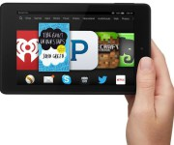 1.

Customer will place an order using tablet or device like tablet.

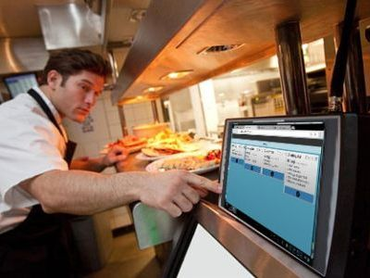

Chef/cook will receive the order directly in kitchen and he will place the food items on a drone.

2.

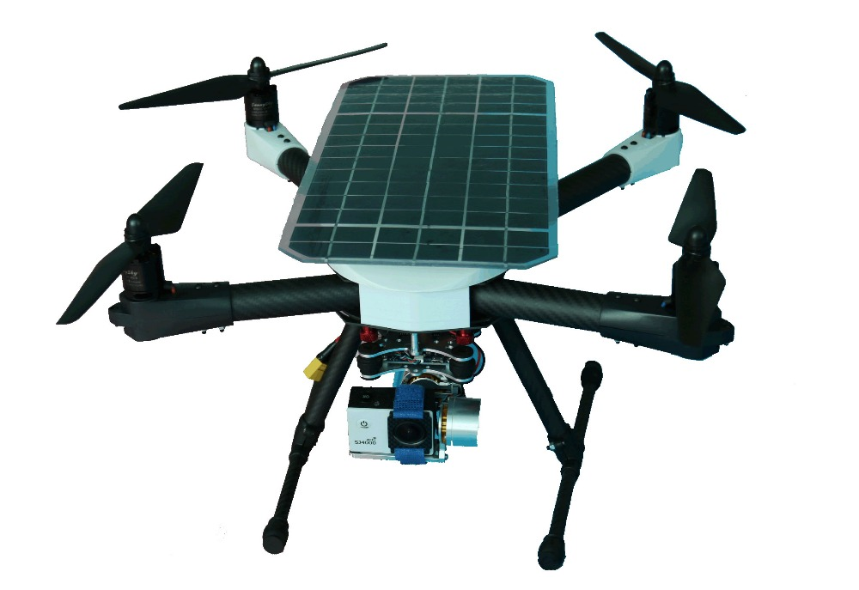

Drone will take the food to the respective table.

3.

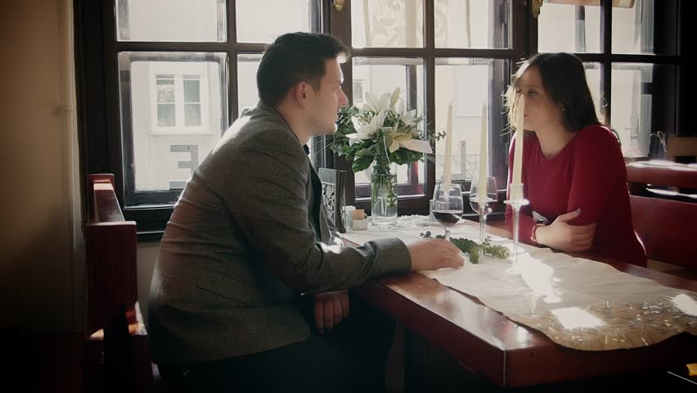

The customer places an order using a tablet, this order is shown to the chef using a display enabled device. The chef prepares the food and then places it on a carrying plate on top of the drone, the chef also has a series of button to specify the table number where the drone needs to deliver the food. The drone then autonomously flies to that tablet number carrying the food placed on top of it and delivers the food to the customer. Each of the table’s location is specified using a software called as Indoor Positioning System where the entire floor plan of the restaurant is mapped to the memory of the device and RFIDs are placed in each table to identify the table uniquely. Once the customer finishes eating the food, he can either thrash the food or there can be a person hired to just clear the tables.